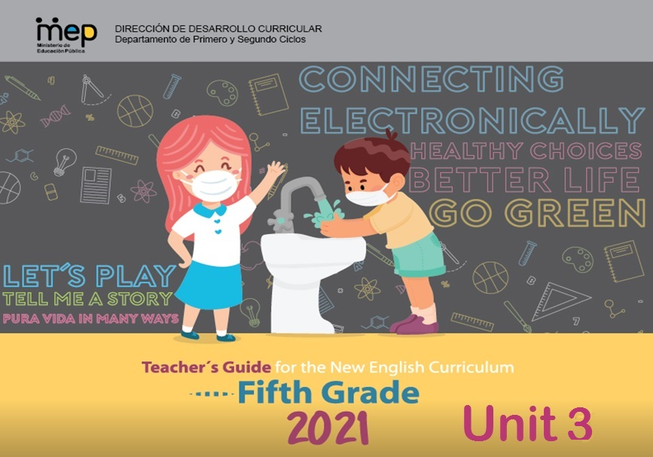

|  |  |  |  |  |
| --- | --- | --- | --- | --- |
| **Level 5th Unit 3**  **Scope and Sequence** | | | | |
| |  | | --- | | **Dimensions** | | **1.** **Ways of thinking ( X )** | | **2. Ways of living in the world  ( X )** | | **3. Ways of relating with others  ( X )** | | **4. Tools for integrating with the world  ( X )** | | | | | |
| **Scenario: Connecting Electronically** | | | | |
| **Enduring Understanding** | Electronic devices are instruments used for a variety of purposes and the ways in which people use them can have positive and negative effects. | | | |
| **Essential  Question** | How can electronic devices help and hurt us? | | | |
| **Assessment and Goals** | | | | |
| **Week 1** | **Week 2** | **Week 3** | **Week 4** | **Week 5** |
| **Theme**   1. Using Electronic Devices | **Theme**   1. At the Electronic Devices Store | **Theme**   1. What is Better a Tablet or a Computer? | **Theme**  4. Operating and Taking Care of Electronic Devices |  |
| **Assessment:**  **L.1.**Recognizes the main points in simple, clear, and short audio announcements and messages.  **R.1.** Recognizes much of what is written in short, simple texts on subjects with which they are familiar and/or in which they are interested.  **R.PA.3.** Reads contractions and word endings -tion, --sion in different sentences and texts.  **Goals:**  **L.1.** understand the main points in simple, clear, and short audio announcements and messages.  **R.1.** understand much of what is written in short, simple texts on subjects with which they are familiar and/or in which they are interested.  **R.PA.3.** Decodes English graphemes and phonemes in different environments. | **Assessment:**  **L.2.**Recognizes the most important points in a straightforward talk or presentation by taking notes and completing a dialogue.  **R.2**. Locates important information in simple texts ( e.g., greetings, times, dates, discourse markers, in a video or radio advertisement or dialogue)  **R.PA.3.** Reads contractions and word endings -tion, --sion in different sentences and texts.  **S.I.1.** Participates in a short telephone conversation prepared in advance.  **Goals:**  **L.2.** understand the most important points in a straightforward talk or presentation, accompanied with drawings and/or diagrams, provided there was some previous familiarity with the topic.  **R.2.** Locate important information in simple texts ( e. greetings, times, dates, discourse markers in a video or radio advertisement or dialogue)  **R.PA.3.** Decodes English graphemes and phonemes in different environments.  **S.I.1.** participate in a short telephone conversation prepared for in advance. | **Assessment:**  **S.I.2.** Expresses common greetings, leave-takings and personal interests in relation to technology in short dialogues and conversations.  **R.PA.3.** Reads contractions and word endings -tion, --sion in different sentences and texts.  **W.1.** Composes short texts expressing uses and ways to take care of personal technological devices.  **Goals:**  **S.I.2.** express common greetings, leave-takings and personal interests in relation to technology in short dialogues and conversations.  **R.PA.3.** Decodes English graphemes and phonemes in different environments.  **W.1.** compose short texts expressing uses and ways to take care of personal technological devices. | **Assessment:**  **S.P.1.** Talks briefly about familiar topics, such as technology.  **R.PA.3.** Reads contractions and word endings -tion, --sion in different sentences and texts.  **W.2.** Composes short dialogues, advertisements related to technological devices and its uses  **Goals:**  **S.P.1.** talk briefly about familiar topics, such as technology.  **R.PA.3.** Decodes English graphemes and phonemes in different environments.  **W.2.** compose short dialogues, advertisements related to technological devices and its uses. | **Assessment**  **Instruments for Process/Product**  **Week 6**  **Suggested Integrated Mini project** |
| **Function**   * Identifying electronic devices | **Function**   * Giving suggestions | **Function**   * Describing advantages and disadvantages of electronics devices related to price and usefulness. | **Function**   * Describing the proper use of electronic devices in my life * Describing the uses of electronic devices in life |
| **Discourse Markers**  Sequence adverbs-past tense  First, next, then, finally | **Discourse Markers**  Sequence adverbs-past tense  First, next, then, finally | **Discourse Markers**  Sequence adverbs-past tense  First, next, then, finally | **Discourse Markers**  Sequence adverbs-past tense  First, next, then, finally |
| **Grammar & Sentence Frames**  There is/are   * There is/are ______.   Adverbial phrases with because   * I like to use ___ because ___ | **Grammar &Sentence Frames**  Simple Preset Tense   * I have a/an _______. * I have a/a_, but I prefer __. * An advantage of internet is _____.     Countable and uncountable   * How much is a MacBook? * How many TVs are there in your home? | **Grammar & Sentence Frames**  Comparative and superlative   * This Mac MP3 is more expensive than that Sony MP3. * The most expensive computer brand in the market is Apple.   Wh/questions   * Which is more expensive this tablet or the cell? * Where can I get the best price in the market? | **Grammar & Sentence Frames**  Modals can/could/should’   * You should buy a _____ (computer) instead of a tablet. * You could ___ get an iPod. |
| **Phonemic Awareness**   * Producing sounds represented by the single-lettered consonant and vowel graphemes. (too, my, me, by) | **Phonemic Awareness**   * Reading roots of words with common prefixes un-, dis-, mega-, micro-, re-, pre-. | **Phonemic Awareness**   * Reading roots of words with common, suffixes like -ful, -ly, -able, -less, -ment and including the endings -tion, -sion. | **Phonemic Awareness**  **Review**   * Reading contractions. (e.g., like haven´t, aren´t, it´s, isn´t, don´t, didn´t, that´s, what´s) in different sentences and texts. |
| **Vocabulary**  **1. Using Electronic Devices**  Electronic devices   * Lap top * smart phone * MP3 * Wii / PS4 * Tablet * EarPods * Smart watch   Actions/Activities   * Listen to music * Send an e-mail * watch videos * chatting * texting * playing games | **Vocabulary**  **2. At the Electronic Devices Store**  Expressions   * How can I help you? * I have a/an____, but I need a/ an ____. * I want a/an______ * How much is a MacBook? It’s____ * Which is more expensive this tablet or the cell? * Where can I get the best price in the market? * You should buy a _____ (computer) instead of a tablet. * What guarantee do you offer? | **Vocabulary**  **3. What is better a tablet or a computer?**  Electronic devices   * Cell phones * Tablets * Desk-top computer * smart boards * smart watches * robots   Adjectives and comparatives   * Expensive * Cheap * Good * Bad * New * Old-fashioned * More memory * Bigger * More accessories | **Vocabulary**  **4.Operating and taking care of electronic devices**  Basic parts of a smartphone   * Power supply * SIM Card * Battery * Key pad * Screen   Action Verbs  How does the phone work?   * Turn on/turn off * Charge the battery. * Click on * To receive a call.   Taking care of electronic devices   * Make sure the device is of good quality. * Charge your phone, but not too often. * Don´t let your device get hot. * Do not let your device get wet. * Make sure Bluetooth is turned off when not in use. * Keep your device clean. |
| **Psycho-social**   * Creating awareness of the negative effects of electronic devices.   **Sociocultural**   * Using memes and emotions appropriately   **Idioms/phrases**  Chatspeak  OMG! (Oh my God) | **Psycho-social**   * Comparing the ways people socialize with or without electronic devices.   **Sociocultural**   * Using memes and emotions appropriately   **Idioms/phrases**  Chatspeak   * lol! (laugh out loud) | **Psycho-social**   * Developing creativity, collaboration critical thinking and communication skills.   **Sociocultural**   * Using of formal and informal language appropriately:   Example: formal, e.g. *Sir, Madam, Miss*, *Dr, Professor* (+ surname) informal, e.g. first name only, such as *John! Susan!*  **Idioms/phrases**  Chatspeak   * XOXO! (hugs and kisses) | **Psycho-social**   * Developing creativity, collaboration critical thinking and communication skills.   **Sociocultural**   * Using of formal and informal language appropriately:   Example: formal, e.g. *Sir, Madam, Miss*, *Dr, Professor* (+ surname) informal, e.g. first name only, such as *John! Susan!*  **Idioms/phrases**  Chatspeak   * G2G (Got to go) |  |

|  |  |  |  |  |  |  |  |  |  |
| --- | --- | --- | --- | --- | --- | --- | --- | --- | --- |
| **Term:** | | **Level: Fifth Grade** | | | **Unit: 3** | | | **Week:1** | |
| **Domain: Socio-interpersonal** | | | | **Scenario:** Connecting Electronically | | **Theme:** Using Electronic Devices | | | |
| **Enduring Understanding**: Electronic devices are instruments used for a variety of purposes and the ways in which people use them can have positive and negative effects. | | | | | | | | | |
| **Essential Question:** How can electronic devices help and hurt us? | | | | | | | | | |
| |  | | --- | | **Dimensions** | | **1.** **Ways of thinking ( X )** | | **2. Ways of living in the world  ( X )** | | **3. Ways of relating with others  ( X )** | | **4. Tools for integrating with the world  ( X )** | | | | | | | | | | |
| **Learn to Know** | | | | **Learn to Do** | | **Learn to Be and Live in Community** | | | |
| **Grammar & Sentence Frames**  There is/are   * There is/are ______.   Adverbial phrases with because   * I like to use ___ because ___   **Phonemic Awareness**   * Producing sounds represented by the single-lettered consonant and vowel graphemes. (too, my, me, by)   **Vocabulary**  **1. Using Electronic Devices**  Electronic devices   * Lap tops * Smart phones * MP3 * Wii * EarPods   Actions/Activities   * listen to music * send an email * watch videos * chatting * texting * playing games | | | | **Function**  Identifying electronic devices  **Discourse Markers**  Sequence adverbs-past tense  First, next, then, finally | | **Psycho-social**   * Creating awareness of the negative effects of electronic devices.   **Socio-cultural**   * Using memes and emotions appropriately   **Idioms/ phrases**  Chatspeak  OMG! (Oh my God) | | | |
| **Assessment Strategies & Evidences of learning**  (Diagnostic, formative, summative) | **Goals** | | | **Pedagogical Mediation/ Didactic Sequence** | | | | | **Time** |
| Learner… | Learner can | | | **Pre-teaching**  **Routine:** Checking attendance, teacher posts the Essential Question on the board, goals, and class agenda, etc.  **Essential Question:** How can electronic devices help and hurt us?  **Warm up**  **Connecting**  The teacher shows a video: **Technology and the family** <https://www.youtube.com/watch?v=37OLJPjoews> and asks students to look at the differences seen in the family according to technology. Then, they brainstorm ideas that the teacher writes on the board.  **Activation of Prior Knowledge**  The teacher shows or sticks on the board some flash cards about electronic devices as laptops, tablets, smartphones, MP 3, Wii, X-box, Nintendo, headphones, EarPods as he/she asks students which ones they use or want in order to have fun and communicate with others. The teacher draws or posts on the board a house and an office where there are some devices and asks students to tell the name of the electronic devices they see. The teacher prompts students to use There is/There are if possible.  **Modeling**  The teacher uses the information given by the students related to electronic devices and makes a list in two columns under the expressions: There is…. /There are….. The teacher makes full sentences and asks students to repeat them (See **Annex 1**).  **Clarification**  **Clarifying**  The teacher pastes the flash cards about electronic devices on the board and asks students to mention the name of each item to make sure they are familiar with the vocabulary. | | | | | Estimated time is calculated by each teacher. |
| **L.1.**Recognizes the main points in simple, clear, and short audio announcements and messages.  **Indicators of learning**  **L1.1.** gets the gist of simple audio messages about technology and electronic devices.  **L.1.2.** recognizes the main points in simple, clear, and short audio announcements and messages about uses of technology and electronic devices. | **L.1.** understand the main points in simple, clear, and short audio announcements and messages. | | | **Connecting**  **Pre-task**  T shares the goal of the lesson  The teacher shows (projects) pictures of some electronic devices such as digital cameras, smartphones, and Alexa (See **Annex 2**). After brainstorming ideas about each device, the teacher writes on the board some phrases related to these electronic devices functions such as: capture moments, take shots, call anywhere, talk, video and chat. The teacher clarifies the vocabulary using pictures (See **Annex 3**) and mimic.  **Clarification**  **Task-rehearsal**  In pairs, one student acts out an action from **Annex 3,** and the partner tells the action.  In the same pairs, one student points to a picture, and the partner makes a full sentence such as: I like to use a digital camera because I can capture moments. They switch roles.  The teacher tells students that they will listen to an audio. The teacher writes the following on the board:  What is the woman talking about?  ( ) The electronic devices that she has.  ( ) Her favorite electronic devices and their functions.  Students compare answers in pairs.  The students listen again and identify the devices mentioned.  <https://recursos.mep.go.cr/sitio_primaria_ingles/quinto.html>  Instructions: Listen to two people mentioning their favorite electronic devices. Look at the pictures and tick the ones you hear inside the brackets.   |  | | --- | | ( )  ( ) ( )  ( ) ( ) |   **Application**  **Task completion**  The teacher gives the students a handout to identify information from the audio about some functions or activities of each electronic device mentioned on the audio.  Instructions: Listen to the audio for a second time and choose the functions mentioned for each electronic device making an (X).   |  |  | | --- | --- | | Digital camera | ( ) capture moments  ( ) take shots under water  ( ) put filters | | Smartphone | ( ) write letters  ( ) talk and record video  ( ) call anywhere |   **Collaboration**  The students sit in pairs to check their responses. The teacher calls students at random to share the answers with the group and gives feedback.  **Task assessment**  The teacher gives the students a handout or asks them to write from the board some functions mentioned on the audio to identify the order in which they were mentioned by writing numbers: 1, 2, 3.  Instructions: Listen to audio again. Next to each electronic device there are some functions mentioned. Order them by placing a number when you hear it inside the brackets.   |  |  | | --- | --- | | Digital camera | ( ) take different shots  ( ) capture moments | | Smartphone | ( ) talk  ( ) call anywhere  ( ) video  ( ) chat |     The teacher asks students to check the answers with his/her partner and claps for students to change partners and share their responses. After that, he / she writes the responses on the board. Students participate in self-assessment of task performance. | | | | |  |
| **R.1.** Recognizes much of what is written in short, simple texts on subjects with which they are familiar and/or in which they are interested.  **Indicators of learning:**  **R1.1.** gets the gist of short simple texts about technology and electronic devices.  **R.1.2.** recognizes general ideas and much of what is written in short, simple texts related with uses of technology and electronic devices. | **R.1.** understand much of what is written in short, simple texts on subjects with which they are familiar and/or in which they are interested. | | | **Connecting**  **Pre-task**  The teacher shows the flash cards (project) to the students to review vocabulary. (See **Annex 2**).  He/She also shows some pictures of the activities or actions you can do using an electronic device (Use **Annex 4**). The teacher asks students to match orally the electronic device with a corresponding activity or action picture. Then, the students check the answers as a group.  The teacher asks students to listen and repeat the actions. He/She introduces the sentence frame I like to use a _____ because I can ____ and writes it on the board.  The teacher shares the goal of the lesson with the students explaining to them that they will be able to understand words and phrases related to electronic devices in a short text.  **Clarification**  **Task-rehearsal**  The students sit in pairs and get some pictures of electronic devices as well as written functions or actions. They have to match the pictures with the corresponding function or action. The teacher calls some students at random to check.  The teacher gives the students a handout to complete a matching exercise to identify the electronic devices and their functions or actions. (See **Annex 5**)  In pairs, one student points to a picture of an electronic device, and his/her partner makes a sentence using the sentence frame.  **Application**  **Task completion**  The teacher writes down on the board (projects or gives a handout) a text for students.  Technology has reinvented the way people communicate. As an example, when using a smartphone people can talk to each other from any place in the world. They can send text messages, share electronic versions of photos, and chat with friends. You can avoid external noise using headphones to listen to your favorite music or to have a great conversation with a friend. A computer is very useful for working or studying from home. You can also watch videos, send emails and share files. There are many video game consoles such as Wii, Nintendo and X-box to play videogames with your family and friends and enjoy a good time together. So, technology is part of our daily lives.  The teacher asks them to read it individually and pick a suitable title for the text.  ( ) Everyday Uses of Technology  ( ) Different Ways to Communicate  Answers are shared.  The teacher reads the text out loud. Then, the teacher asks students to read it again individually. He/She asks students to complete the actions or activities for each electronic device in the blank spaces.   |  | | --- | | Smartphone: a) ______________________  b) ______________________  c) ______________________  Headphones: a) _______________________  Computer / tablet: a) ______________________  b) ______________________  c) ______________________  Video game consoles: a) ______________________ |   **Collaboration**  Then, the students share their answers and the teacher writes them on the board to clarify and give feedback.  **Task assessment**  The teacher gives the students a handout to read and complete the sentences placing the name of the electronic device based on the given characteristics (See **Annex 6**). After they finish, they compare their responses in pairs and some students called at random say the answers out loud for the group to check. Students participate in self-assessment of task performance. | | | | |  |
| **R.PA.3.** Reads contractions and word endings -tion, --sion in different sentences and texts.  **Indicator of learning**  **R.PA.3.1.** produces sounds represented by single-lettered consonant and vowel graphemes (too, my, me, by) when reading sentences. | **R.PA.3.** Decodes English graphemes and phonemes in different environments. | | | **Connecting**  **Pre-task**  The teacher writes down the following words on the board (projects them): no, my, me, by, go, be, too, see. He/She asks them: How many of those words can you read correctly? Students are given a few seconds to take a look at them and think about how many they can read correctly.  Then, the teacher is going to ask the students to sit down in pairs and take turns reading the words to see if they agree on the pronunciation of the words.  After that, the teacher points to every word at a time and asks students to say the word out loud. Then, he/she pronounces the word.  The teacher introduces the goal of the lesson: reading consonant + vowel words  **Clarification**  **Task-rehearsal**  The teacher reads every word out loud and asks the students to repeat after him/her.  The teacher writes down(projects/hands in a copy) the following sentences on the board:   1. **My** favorite electronic device is the smartphone. 2. My parents gave **me** one for Christmas. 3. I **see** that many of my friends have one, too. 4. I have to **be** very responsible with my phone. 5. I always put it in my backpack when I **go** to school. 6. At school, there is **no** good connection. 7. **By** the end of this year, the school will have Wi-Fi connection for all of us.   The teacher reads the sentences and asks students to listen and repeat, paying extra attention to the words presented before.  Students sit down in pairs and take turns reading the sentences out loud. The partner can give feedback as they are doing it.  In new pairs, one student points to one sentence, and the partner reads it.  **Application/ Collaboration**  **Task completion**  The teacher asks students to write down the sentences in their notebooks (gives them a handout). In pairs, student exchange notebooks (handouts). One student reads all the sentences out loud at a time. The partner writes down a check mark next to the words that were pronounced correctly. Students switch roles.  **Task assessment**  The teacher takes the list of sentences and cuts it out into individual sentences. He/She puts the sentences in a paper bag. He/She calls out one pair of students at a time and asks them to take out a sentence and read it out loud in front of the group. Students participate in self-assessment of task performance.  **Student self-assessment grid**   |  |  |  |  | | --- | --- | --- | --- | |  | Level of achievement | | | | Assessment Indicators  I can ... | Not achieved yet | In progress | Achieved | | L1.1. gets the gist of simple audio messages about technology and electronic devices. |  |  |  | | L.1.2. recognizes the main points in simple, clear, and short audio announcements and messages about uses of technology and electronic devices |  |  |  | | R1.1. gets the gist of short simple texts about technology and electronic devices. |  |  |  | | R.1.2. recognizes general ideas and much of what is written in short, simple texts related with uses of technology and electronic devices |  |  |  | | **R.PA.3.1.** produces sounds represented by single-lettered consonant and vowel graphemes (too, my, me, by) when reading sentences. |  |  |  | | | | | |  |
| **Integrated Mini-Project** | | | | | | | | | **Time** |
| In small groups,  - Planning, creating collaboratively a technology exhibition in the classroom describing each device (price, advantages and disadvantages) and their corresponding definition using flashcards, articles and magazine clippings for reporting to small groups or whole class.  - Another idea is creating a poster of one or more specific device(s) (drawings, brainstorming, ways to take care, advantages and disadvantages)  - Make a collage with drawings, magazine clippings, articles and all the vocabulary seen in class.  - Participating in individual assessment. In all activities, encourage students to ask presenters different questions. | | | | | | | | |  |
| **Reflective Teaching** | | | | | | | | | |
| What worked well | | | What didn’t work well | | | | How to improve | | |
| **Enduring Understanding Reflection** | | | | | | | | | |
|  | | | | | | | | | |

**Annex 1**

There is a(n) ___________ in my house / the office. There are ______________ in my house / the office.

laptop  (two) laptops

 tablet  tablets

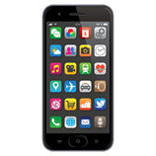smartphone  smartphones

 headphones

 EarPods

**Annex 2**

  

Laptop Amazon Alexa Tablet

  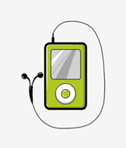

Smartphone Digital camera MP 3

  

Headphones EarPods Nintendo

 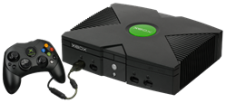 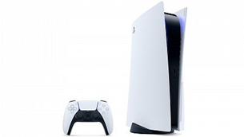

Wii X-box Play Station

**Annex 3**

   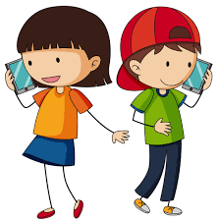

capture moments take shots call anywhere talk

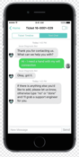



video

chat

**ANNEX 4**

**Actions or Activities**

   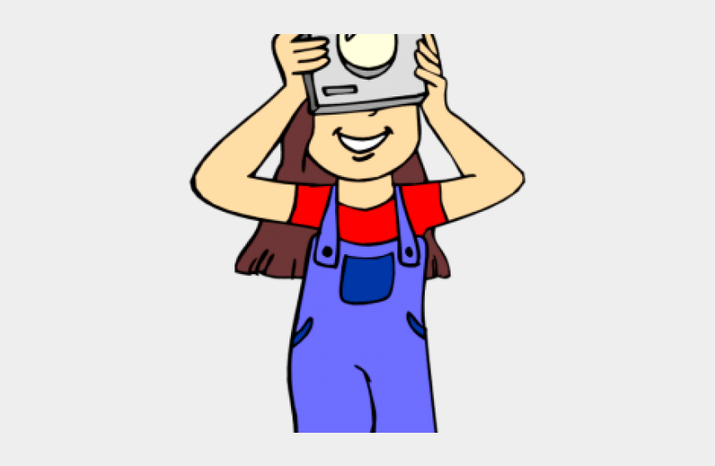

Listen to music Send an e-mail Watch videos Take pictures

   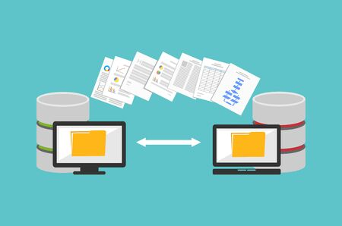

Chat (chatting) with friends Text (texting) Playing video games Share files

**Annex 5**

Look at the pictures of electronic devices at the left. Then, match the pictures with some of its functions or actions at the right by tracing a line.

|  |  |  |
| --- | --- | --- |
| A computer |  | to listen to music |
| A video game console |  | to text with friends |
| Headphones |  | to send emails |
| A smartphone |  | to play videogames |

**Annex 6**

Look at the pictures, then complete the sentences according to the activity you can do with each electronic device and place the number of each one in the square.

|  |
| --- |
| HEADPHONES – COMPUTER – SMARTPHONE – VIDEO GAME CONSOLE |

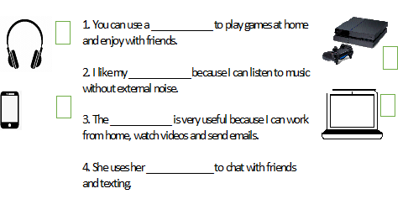

|  |  |  |  |  |  |  |  |  |  |
| --- | --- | --- | --- | --- | --- | --- | --- | --- | --- |
| **Term: II** | | **Level: Fifth Grade** | | | **Unit: 3** | | | **Week:2** | |
| **Domain: Socio-interpersonal** | | | | **Scenario:** Connecting Electronically | | **Theme:** At the Electronic Devices Store | | | |
| **Enduring Understanding**: Electronic devices are instruments used for a variety of purposes and the ways in which people use them can have positive and negative effects. | | | | | | | | | |
| **Essential Question:** How can electronic devices help and hurt us? | | | | | | | | | |
| |  | | --- | | **Dimensions** | | **1.** **Ways of thinking ( X )** | | **2. Ways of living in the world  (X )** | | **3. Ways of relating with others  (X )** | | **4. Tools for integrating with the world  (X )** | | | | | | | | | | |
| **Learn to Know** | | | | **Learn to Do** | | **Learn to Be and Live in Community** | | | |
| **Grammar & Sentence Frames**  Simple Preset Tense   * I have a/an _______. * I have a/a_, but I prefer __. * An advantage of internet is _____.     Countable and uncountable   * How much is a MacBook? * How many TVs are there in your home?   **Phonemic Awareness**   * Reading roots of words with common prefixes un-, dis-, mega-, micro-, re-, pre-.   **Vocabulary**  **2. At the Electronic Devices Store**  Expressions   * How can I help you? * I have a/an____, but I need a/an ____. * I want a/an______ * How much is a MacBook? It’s____ * Which is more expensive, this tablet or the cell? * Where can I get the best price in the market? * You should buy a _____ (computer) instead of a tablet. | | | | **Function**  Giving suggestions  **Discourse Markers**  Sequence adverbs-past tense  First, next, then, finally | | **Psycho-social**   * Comparing the ways people socialize with or without electronic devices.   **Socio-cultural**   * Using memes and emotions appropriately   **Idioms/ phrases**  Chatspeak  Lol! (laugh out loud) | | | |
| **Assessment Strategies & Evidences of learning**  (Diagnostic, formative, summative) | **Goals** | | | **Pedagogical Mediation/ Didactic Sequence** | | | | | **Time** |
| Learner… | Learner can | | | **Pre-teaching**  **Routine:** Greeting students, checking attendance, checking-in with students and go over any assignment.  **Connecting**  **Warm up**  The teacher downloads the game ROULETTE (See **Annex 1**): You can see what it looks like in the following link: <https://drive.google.com/file/d/1PzesRYtIa7pTLCEZCTofLR7J-zZMVSSs/view?usp=sharing> to review the vocabulary from last week: Lap top, smartphone, MP3, Wii / PS4, Tablet, EarPods, Smart watch, microphone. It is a Power Point presentation. The teacher tells a student to start. When the teacher touches the START button, the roulette starts moving, then the student says STOP and the teacher touches the button again. The arrow shows a number, the students finds the picture with the number and says which object it is. The teacher continues with two or more students.  **Note**: The teacher can also use the template in the Annexes to make the roulette in cardboard.  **Activation of Prior Knowledge**  The teacher asks learners: Where can you buy electronic devices? How much does a cell phone cost? Does your family have a computer? He/she listens to the students and writes their responses on the board. Brainstorm about different places to buy electronic devices and forms to buy in the store or on-line.  **Modeling**  The teacher uses the following examples to explain how to use discourse markers in context using electronic devices´ names.  Examples: First, I go to the electronic device store. Next, I ask for the electronic devices. Then, I choose an electronic device that I want to buy. Finally, I buy the electronic device.  **Clarification**  **Clarifying**  The teacher shows the students some pictures or flashcards about electronic devices (See **Annex 2**)and the learners have to recognize them. For this purpose, the teacher makes some sentences about the pictures, and the students have to say which is the picture being described. | | | | |  |
| **L.2.**Recognizes the most important points in a straightforward talk or presentation by taking notes and completing a dialogue.  **Indicator of learning:**  **L1.1.** gets the gist of the most important points in a straightforward talk or presentation about technology and electronic devices provided there was some previous familiarity with the topic.  **L.1.2.** recognizes the most important key points in a straightforward talk or presentation, about technology and electronic devices accompanied with drawings and/or diagrams, provided there is some previous familiarity with the topic.  **R.2**. Locates important information in simple texts ( e.g., greetings, times, dates, discourse markers, in a video or radio advertisement or dialogue)  **Indicator of learning:**  **R.2.1**. recognizes key vocabulary in short simple texts such as greetings, times, dates and discourse markers related with technology and ways to take care of electronic devices.  **R.2.2.** locates important information in simple texts related with technology and ways to take care of electronic devices (e.g., greetings, times, dates, discourse markers, in a video or radio advertisement or dialogue). | **L.2.** understand the most important points in a straightforward talk or presentation, accompanied with drawings and/or diagrams, provided there was some previous familiarity with the topic.  **R.2.** Locate important information in simple texts ( e. greetings, times, dates, discourse markers in a video or radio advertisement or dialogue) | | | **Connecting**  **Pre-task**  The teacher shares the goal of the lesson.  The teacher plays the audio of a conversation and asks students to identify the electronic device that is mentioned. (answer: a smartphone)  Audio:  <https://recursos.mep.go.cr/sitio_primaria_ingles/quinto.html>  Students share their answers.  The teacher introduces some key words/expressions from the audio (See **Annex 3**) by showing them the pictures, pronouncing the words, giving examples with each word and gestures to make their meaning clear.  **Clarification**  **Task-rehearsal**  Teacher points to each picture and makes a sentence, and learners repeat.  In pairs, using the same picture, one student says a number and the other says the word or the sentence. It depends on every student’s level. The idea is to practice the new words. Have students switch roles.  Using **Annex 4**, one student calls a number at random, and the classmate says the corresponding word/sentence. Students switch roles.  Optional: In pairs, one student acts out/draws/describes one word, and the other says the word/sentence.  **Application**  **Task completion**  Give your students the copy on **Annex 5** or write down the questions on the board. Read them with your students and clarify them.  Play the audio a first time and ask your students to just listen. (Script on **Annex 6**)  Play it a second time and ask them to answer the questions.  Play it a third time for them to finish answering or reviewing their answers.  Go over your students’ answers. You may ask them to compare answers in pairs.  **Collaboration**  **Task assessment**  Students discuss, in small groups, about one of the electronic devices that they have and explain what important characteristics it has by using the information from the conversation.  I have a(an) ___. I like it because it ____. Students participate in self-assessment of task performance.  **Connecting**  **Pre-task**  The teacher shows to her/his students some pictures related to electronic devices. The teacher asks her /his students if they know the names of each picture.  As the students say the teacher of the devices, the teacher writes them on board. It is ok if they do not know some of them.    The teacher shows the picture of a laptop and a tablet/writes the words on the board and writes the following questions on the board:  What is better: a laptop or a tablet? Why?  The teacher asks students to discuss both questions in pairs.  Then, pairs share their answers with the rest of the group. The teacher writes the students answers on the board. He/She uses a sentence frame such as: The tablet is better because it is small.  The teacher shares the goal of the lesson in simple words with the students. He/She tells them that they have to find some important information about electronic devices in a text a short text.  **Clarification**  **Task-rehearsal**  The teacher gives/projects/shows his/her students the handout in **Annex 7** and asks them to try to match the words listed with the pictures given. It is ok if they do not know some. Just ask the students to make an educated guess. Use the “Think, Pair and Share” strategy. (The annex has a color and black & white version)  The teacher asks volunteers to share their answers, and he/she explains a little more about each word, its meaning and use.  The teacher gives students one example per word and asks them to repeat after him/her.  In pairs, one student covers the words with a piece of paper or ruler, and his/her classmate calls out a word, and the other one has to point to the right picture. A variation would be to ask one student to point to the picture and have the classmate say the word. (**Note**: if the teacher gives his/her students sentences, he/she can ask the students to do the activities with sentences. It is better to use the words in context.)  **Application/ Collaboration**  **Task Completion**  The teacher gives the article below to his/her students.  And 1) He/She asks them to read the subtitle and write down the names of the two electronic devices mentioned.  2) He/She asks them to read the text and complete the organizer below. The teacher reads the organizer with the students and explains what the expectation is.      **Task assessment**  In pairs, the students have a conversation. They are friends and one of them wants to buy a tablet or a computer. The other student gives reasons why he/she should buy one or the other. They can use the information from the chart and this sentence frame or a similar one:  I think you should buy a ________ because you can _______. Students participate in self-assessment of task performance. | | | | |  |
| **R.PA.3.** Reads contractions and word endings -tion, --sion in different sentences and texts.  **Indicator of learning:**  **R.PA.3.2.** identifies roots of words with common, prefixes un-, dis-, mega-, micro-, re-, pre- in sentences and short texts.  **R.PA.3.3.** reads roots of words with common prefixes un-, dis-, mega-, micro-, re-, pre- in sentences and short texts. | **R.PA.3.** Decodes English graphemes and phonemes in different environments. | | | **Connecting**  **Pre-task**  The teacher writes down the following words on the board:  **“**un - plug = unplug”  **“**re - start = restart”  “dis - connect = disconnect”  “pre - pay = prepay”  “mega - byte = megabyte”  “micro - phone = microphone”  The teacher asks students if they know how the prefix changes the meaning of the words and how? Use the Think, Pair, Share strategy to go over the question (Think: students think individually of the answer. Pair: students share answers in pairs. Share: volunteers share answers with all the group).  After students participate, the teacher explains what prefixes (beginning) are and complements their answers by explaining how they change the meaning of the words in the examples. Teacher explains the meaning of the root and the meaning with the prefix.    T shares the goal of the lesson.  **Clarification**  **Task-rehearsal**  The teacher writes down or makes a PP presentation with the following sentences:   1. Once the telephone is fully charged, remember to unplug it. 2. If at any time, you have no internet, disconnect the power cable from the modem. Then, reconnect the cable. Most of the time, you have to restart your telephone. 3. I have a prepay internet service for my phone. 4. My phone has a 25 megabyte connection. 5. For my virtual classes, I bought some headphones with a good microphone.   The teacher tells the students to listen and repeat the sentences paying special attention to the underlined words.    The teacher asks the students to get in pairs. One student calls a number, and the other reads the sentence. They give each other feedback on how well each word is pronounced.  **Application/ Collaboration**  **Task completion**  Students get in pairs and take turns reading the sentences. When one student is finished, the other gives feedback in terms of how many right words he/she pronounced and gives the right pronunciation if necessary.  **Task assessment**  The teacher calls out one prefix at a time, and the students read the sentence that has the word with that prefix. Students participate in self-assessment of task performance. | | | | |  |
| **S.I.1.** Participates in a short telephone conversation prepared in advance.  **Indicator of learning:**  **SI.1.1.** elaborates a draft of a telephone conversation with a clerk in gadget store in a collaborative way using questions, key words and phrases.  **SI.1.2.** interacts with a peer a role-play of a telephone conversation with a clerk in gadget store using questions, key words and phrases as a form of rehearsal. | **S.I.1.** participate in a short telephone conversation prepared for in advance. | | | **Connecting**  **Pre-task**  The teacher tells the students that he/she has a son/daughter/brother/sister who needs a computer for school work. The teacher tells them that he/she is going to call an electronics store. The teacher asks students to sit down in pairs and brainstorm what questions should the person ask the salesperson and what information is important to consider. The teacher writes “Questions” on one side of the blackboard and “Important information” on the other side.  The teacher writes down the students responses on the board.  The teacher presents the goal of the lesson: They will prepare a telephone conversation about purchasing an electronic device.  The teacher introduces the new expressions and vocabulary (See **Annex 8**). He/She reads the sentences and explains a little the meaning of the words.  **Clarification**  **Task-rehearsal**  The teacher reads the sentences. The students listen and repeat.  In pairs, one student acts out a word, and the other says the word. They switch roles.    The teacher plays the conversation (Script in **Annex 9**)  <https://recursos.mep.go.cr/sitio_primaria_ingles/quinto.html>  and asks students to take notes about the questions that the person asks and the characteristics of the device.     |  |  | | --- | --- | | Questions that the woman asks | Characteristics mentioned of both devices | |  |  |   The teacher projects/gives a copy/writes down the conversation for the students to practice for pronunciation. The teacher plays the audio one more time. Then, asks students to practice.  **Task**: One of students needs to buy an electronic device for school work. He/She calls a store to get information about the best option. The salesperson gives information and gives recommendations.  The teacher asks students to sit down in pairs and prepare a draft of their conversation. They should jot down some ideas, expressions and sentences to organize their conversation. Once they have it ready, the teacher asks them to rehearse their conversation. It is advisable that students switch roles and use other technological devices.  **Application/ Collaboration**  **Task completion**  When students are ready, the teacher listens to them. The teacher may consider allowing students to record their conversation. The teacher can also walk around the group and carry out his/her assessment for every pair. Some others will present their conversation in the front of the class.  **Task assessment**  Based on the conversation, students will pretend to send a text message or email to one of his/her parents telling him/her the electronic device that they want to buy. They give reasons (characteristics and price) for their choice. They can use a cell phone or tablet if they have one, or simply write down the message on a piece of paper and exchange that piece of paper with other classmates for them to read. Students participate in self-assessment of task performance. Example:  Hi mom! I need a ________ for school. I want to buy a ______ because ___________.  **Student self-assessment grid**   |  |  |  |  | | --- | --- | --- | --- | |  | Level of achievement | | | | Assessment Indicators  I can... | Not achieved yet | In progress | Achieved | | **L1.1.** gets the gist of the most important points in a straightforward talk or presentation about technology and electronic devices provided there was some previous familiarity with the topic. |  |  |  | | **L.1.2.** recognizes the most important key points in a straightforward talk or presentation, about technology and electronic devices accompanied with drawings and/or diagrams, provided there is some previous familiarity with the topic. |  |  |  | | **R.2**. Locates important information in simple texts ( e.g., greetings, times, dates, discourse markers, in a video or radio advertisement or dialogue)  **Indicator of learning:**  **R.2.1**. recognizes key vocabulary in short simple texts such as greetings, times, dates and discourse markers related with technology and ways to take care of electronic devices. |  |  |  | | **R.2.2.** locates important information in simple texts related with technology and ways to take care of electronic devices (e.g., greetings, times, dates, discourse markers, in a video or radio advertisement or dialogue). |  |  |  | | **R.PA.3.2.** identifies roots of words with common, prefixes un-, dis-, mega-, micro-, re-, pre- in sentences and short texts. |  |  |  | | **R.PA.3.3.** reads roots of words with common prefixes un-, dis-, mega-, micro-, re-, pre- in sentences and short texts. |  |  |  | | **SI.1.1.** elaborates a draft of a telephone conversation with a clerk in gadget store in a collaborative way using questions, key words and phrases. |  |  |  | | **SI.1.2.** interacts with a peer a role-play of a telephone conversation with a clerk in gadget store using questions, key words and phrases as a form of rehearsal. |  |  |  | | | | | |  |
| **Integrated Mini-Project** | | | | | | | | | **Time** |
| In small groups,  - Planning, creating collaboratively a technology exhibition in the classroom describing each device (price, advantages and disadvantages) and their corresponding definition using flashcards, articles and magazine clippings for reporting to small groups or whole class.  - Another idea is creating a poster of one or more specific device(s) (drawings, brainstorming, ways to take care, advantages and disadvantages)  - Make a collage with drawings, magazine clippings, articles and all the vocabulary seen in class.  - Participating in individual assessment. In all activities, encourage students to ask presenters different questions. | | | | | | | | |  |
| **Reflective Teaching** | | | | | | | | | |
| What worked well | | | What didn’t work well | | | | How to improve | | |
| **Enduring Understanding Reflection** | | | | | | | | | |
|  | | | | | | | | | |

**Annex 1**

**Warm Up - Roulette -** <https://drive.google.com/file/d/1PzesRYtIa7pTLCEZCTofLR7J-zZMVSSs/view?usp=sharing>

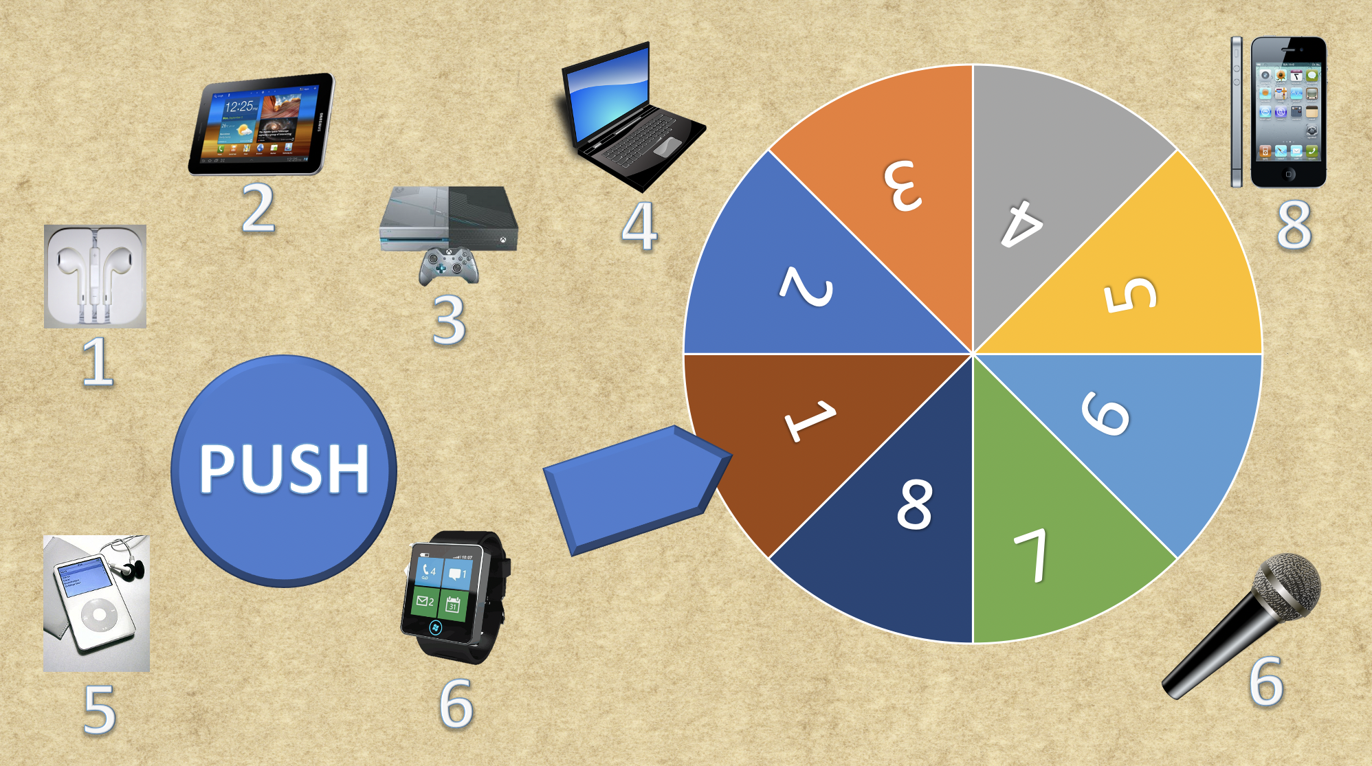

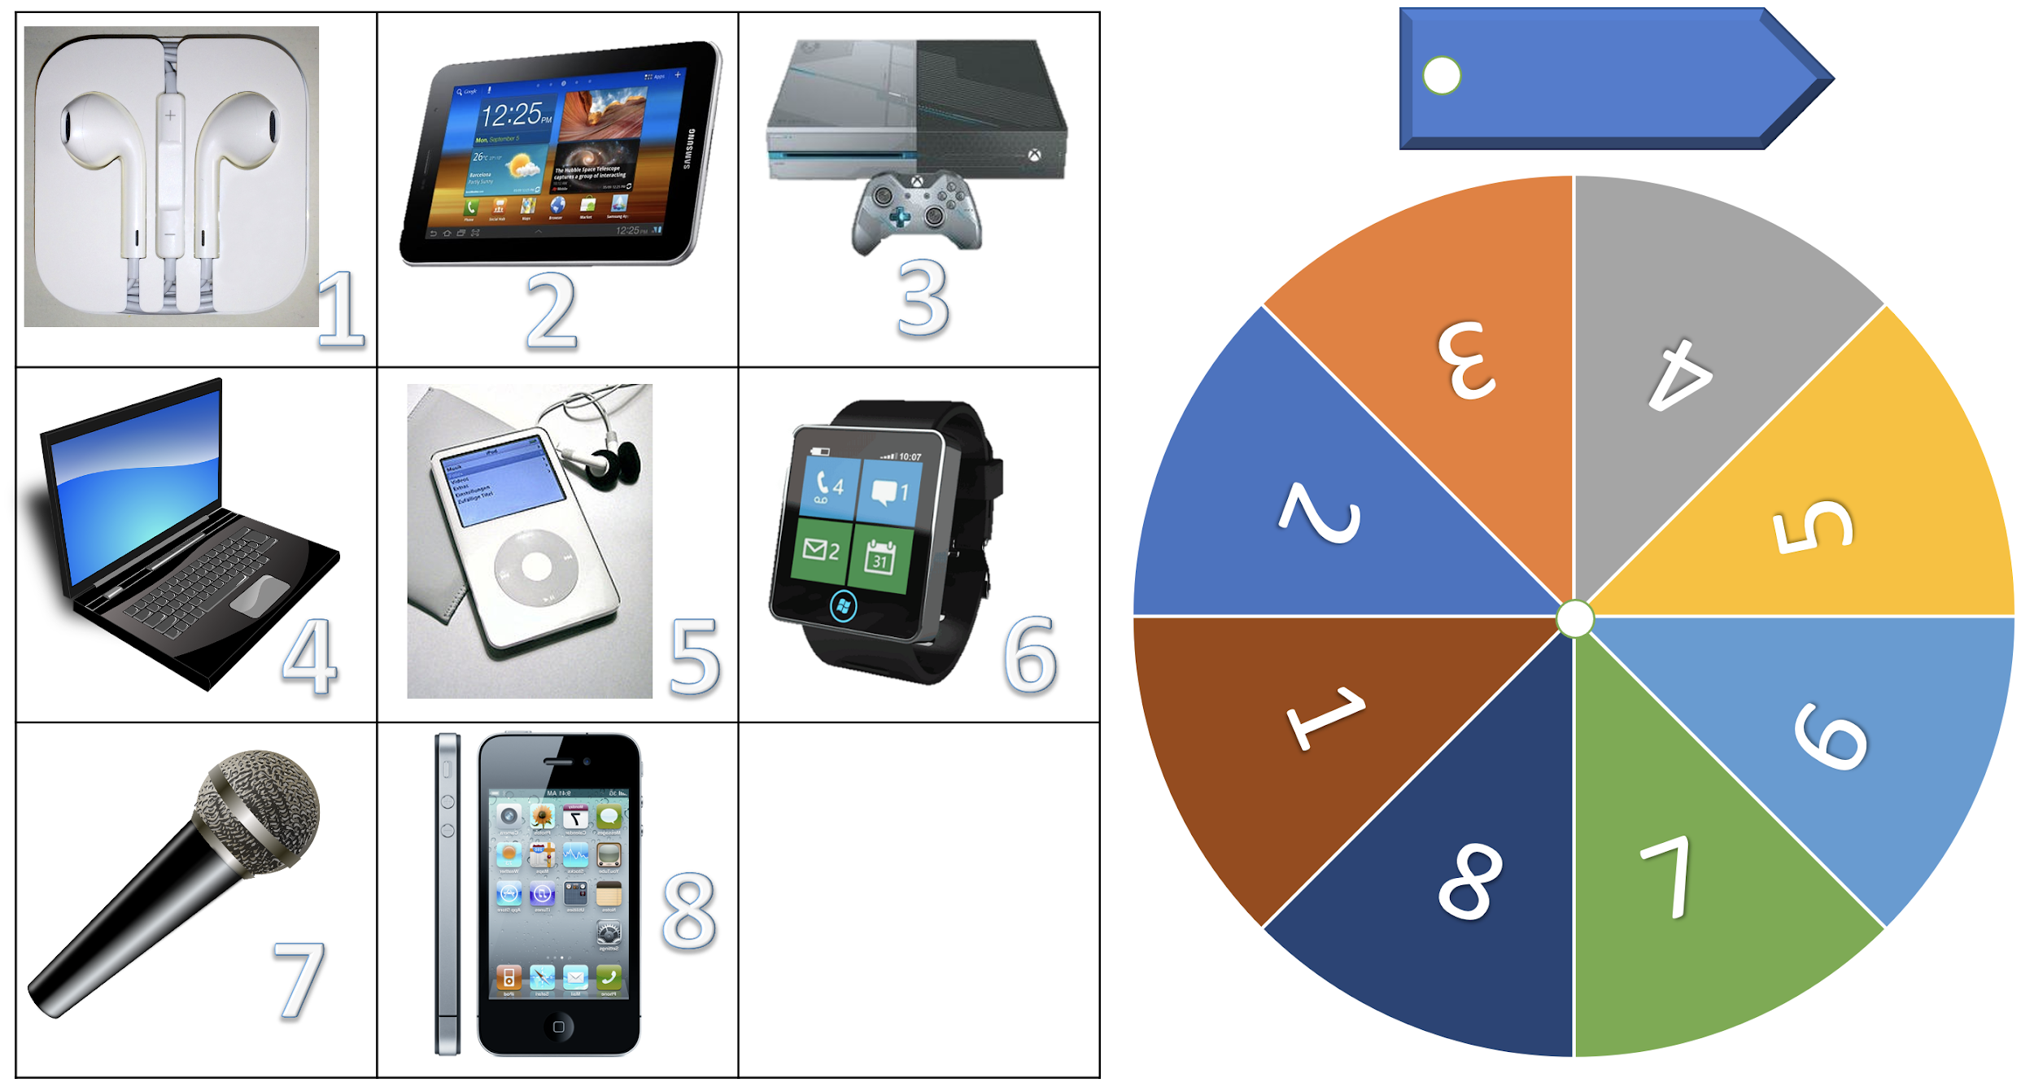

**Annex 2**

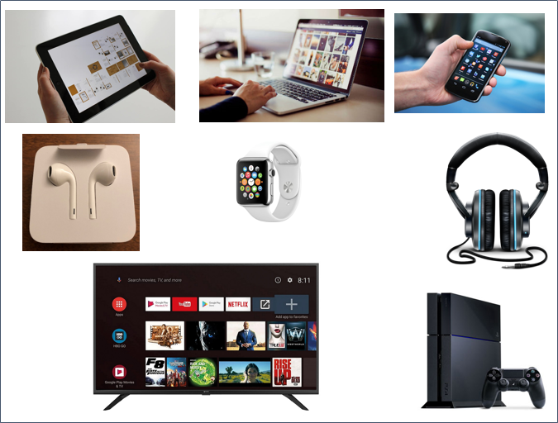

**Annex 3**

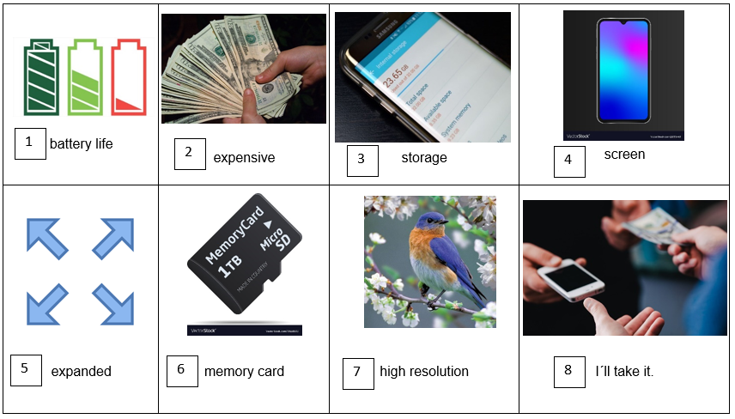

**Annex 4**

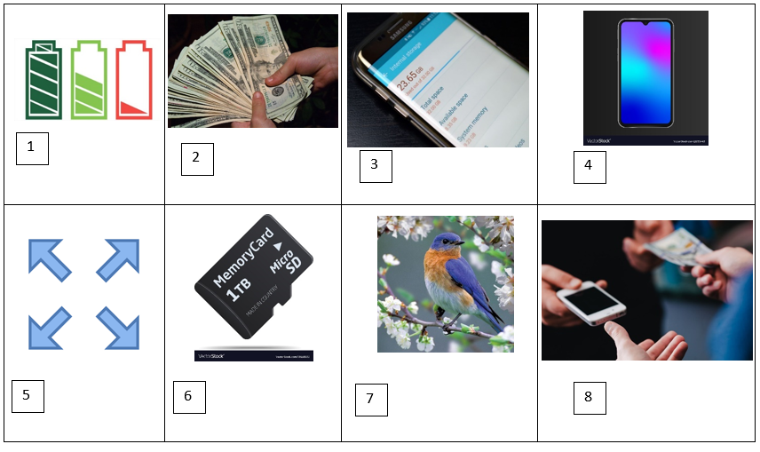

**Annex 5**

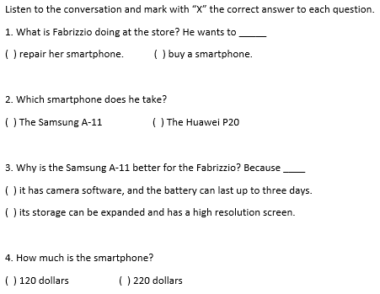

**Annex 6**

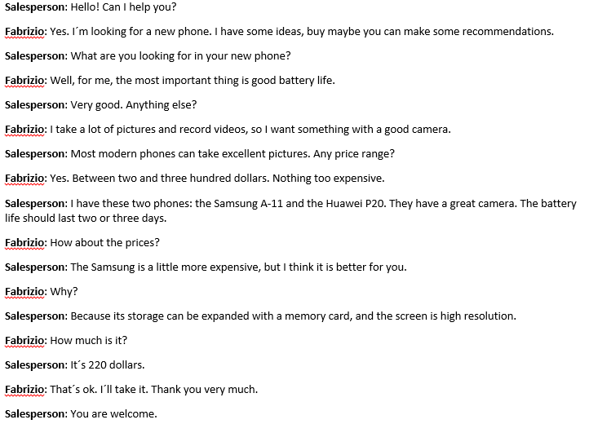

**Annex 7**

1. homeschool 2. navigate 3. platform 4. submit

5. message 6. type 7. take notes 8. save

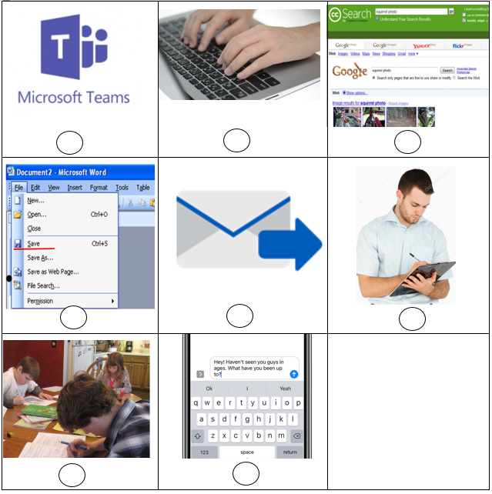

1. homeschool 2. navigate 3. platform 4. submit 5. type 6. take notes 7. save

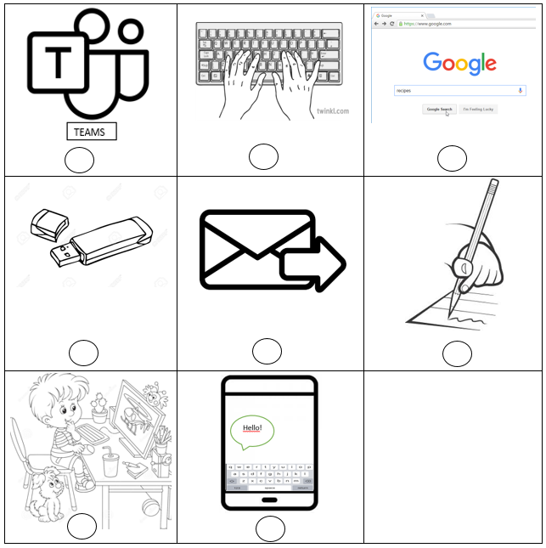

**Some extra words that you can use for Reading Phonemic Awareness**

|  |  |  |
| --- | --- | --- |
| unsafe | dislike | megahertz |
| microphone | reheat | prepay |
| unlike | dishonest | megabyte |
| unfair | megapixels | microwave |
| disagree | replay | pretest |
| microprocessor | redo | preview |

**Annex 8**

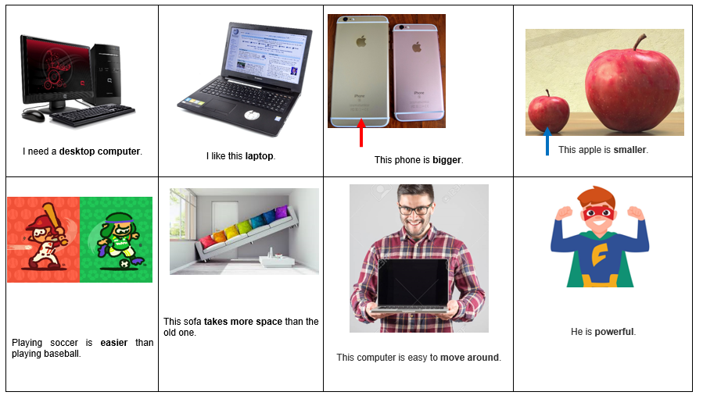

**Annex 9**

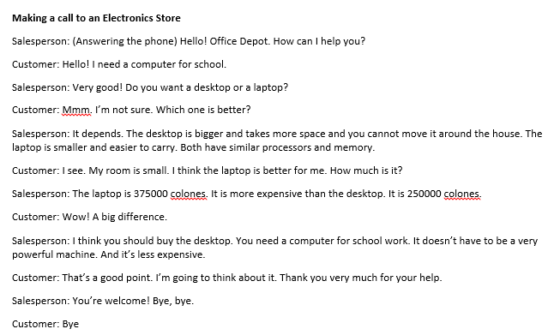

|  |  |  |  |  |  |  |  |  |  |
| --- | --- | --- | --- | --- | --- | --- | --- | --- | --- |
| **Term: II** | | **Level: Fifth Grade** | | | **Unit: 3** | | | **Week:3** | |
| **Domain: Socio-interpersonal** | | | | **Scenario:** Connecting Electronically | | **Theme:** What is Better a Tablet or a Computer? | | | |
| **Enduring Understanding**: Electronic devices are instruments used for a variety of purposes and the ways in which people use them can have positive and negative effects. | | | | | | | | | |
| **Essential Question:** How can electronic devices help and hurt us? | | | | | | | | | |
| |  | | --- | | **Dimensions** | | **1.** **Ways of thinking ( X )** | | **2. Ways of living in the world  ( X )** | | **3. Ways of relating with others  ( X )** | | **4. Tools for integrating with the world  ( X )** | | | | | | | | | | |
| **Learn to Know** | | | | **Learn to Do** | | **Learn to Be and Live in Community** | | | |
| **Grammar & Sentence Frames**  Comparative and superlative   * This Mac MP3 is more expensive than that Sony MP3. * The most expensive computer brand in the market is Apple.   Wh/questions   * Which is more expensive this tablet or the cell? * Where can I get the best price in the market?   Modals can/could/should’   * You should(n’t) ________ * You should ____. * You could ___ an iPod.   **Phonemic Awareness**  Reading roots of words with common, suffixes like -ful, -ly, -able, -less, -ment and including the endings -tion, -sion.  **Vocabulary**  **3. What is better a tablet or a computer?**  Electronic devices   * Cell phones * Tablets * Desk-top computer * smart boards * smart watches * robots   Adjectives   * Expensive * Cheap * Good * Bad * New * Old fashioned | | | | **Function**  Describing advantages and disadvantages of electronics devices related to price and usefulness.  **Discourse Markers**  Sequence adverbs-past tense  First, next, then, finally | | **Psycho-social**   * Developing creativity, collaboration critical thinking and communication skills.   **Socio-cultural**   * Using of formal and informal language appropriately:   Example: formal, e.g. *Sir, Madam, Miss*, *Dr, Professor* (+ surname) informal, e.g. first name only, such as *John! Susan!*  **Idioms/ phrases**  Chatspeak  XOXO! (hugs and kisses) | | | |
| **Assessment Strategies & Evidences of learning**  (Diagnostic, formative, summative) | **Goals** | | | **Pedagogical Mediation/ Didactic Sequence** | | | | | **Time** |
| Learner… | Learner can | | | **Pre-teaching**  **Routine:** Checking attendance, checking in with Ls, T posts the Essential Question on the board and class agenda, etc.  **Warm up**  **Connecting**  Option #1: The class is divided into groups of four people. The teacher gives each team some examples of electronic devices that they can use and classify them by their price in two groups.  cheap  expensive  The teacher shows the devices of each box. Which one is cheaper? Which brand is more popular?  HP Laptop $600  ACER Laptop $350  1. 2.  The teacher provides more information (sentences) about electronic devices in general and asks the students to classify each sentence as “an advantage” or “a disadvantage”. The teacher uses the two computers to explain the meaning of the two words. For example:  The HP Laptop has more storage than the Acer Laptop. (advantage)  The Acer Laptop has a small keyboard. (disadvantage)  Example:  -Television shows are entertaining. Advantage  - A lot of channels available without the need to subscribe to a cable service. Advantage  -Smart TVs provide gaming and web browsing. Advantage  -Threat of Cyber Attack. Disadvantage  - Risk of getting virus. Disadvantage  -You are always online. Disadvantage  -Smart TVs can crash just like a computer. Disadvantage  Option #2: Students play the price is right! Students guess the price of each electronic device given by the teacher. The student who gets closer to the correct price wins. (See **Annexes 1** & **2** for the list of devices and prices)    **Activation of Prior Knowledge**   * Describing the electronic devices. Learners and teacher make a list of words used to describe the following devices:     (Entertaining/ Modern/Expensive)    (Old- fashioned/ Interesting)  (Less functional/old-fashioned)  **Modeling**  Resultado de imagen para computersThe teacher makes some comparisons about advantages and disadvantages of some electronic devices.  Laptops are more expensive than desktop computers. versus  Laptops are more modern than desktop computers.  Desktop computers take more space than laptops.  Play Station has the best resolution. It is the best!  **Clarification**  **Clarifying**  Learners observe the teacher as he/she sticks the picture of electronic devices on the board and listen to the teacher saying, for example, *“A tablet is smaller than a computer.” The learners agree or disagree.* If the statement is true, the students raise their hands*.* | | | | |  |
| **S.I.2.** Expresses common greetings, leave-takings and personal interests in relation to technology in short dialogues and conversations.  Indicator of learning:  **S.I.2.1.** asks and responds to questions about greetings and personal interests related with technology in short dialogues and conversations.  **S.I.2.2.** expresses common greetings, leave-takings and personal interests in relation to technology in short dialogues and conversations. | **S.I.2.** express common greetings, leave-takings and personal interests in relation to technology in short dialogues and conversations. | | | **Connecting**  **Pre-task**  The teacher shows students a picture (See **Annex 3** the teacher can bring a tablet and use his/her laptop to make it more meaningful from a visual point of view) and asks them: What do you think Valeria and Joshua are talking about?  The teacher asks students to brainstorm ideas in pairs. Then, he/she asks for volunteers to share their ideas.  After listening to the students’ answers, the teacher introduces the goal of the lesson: they will learn to express personal interests, advantages and disadvantages in relation to technology in a conversation.  Valeria and Joshua are talking at an electronics store about their devices. They are comparing them. What do you think that they are saying? Ask them to work in pairs and encourage them to use the following words (They should know some of them already):  thinner, lighter, easier, **storage capacity**, **battery life**, **expensive**  As the students participate, the teacher writes down some of their examples on the board. If the students do not know the meaning of one word, the teacher can give them an example with the laptop and tablet that he/she brought. For example: The teacher can call a student to the front and ask the student to weigh both devices. Then, the teacher can ask the student: Which one is lighter? After the student, answers the question, the teacher writes a full sentence to illustrate such as: The tablet is lighter than the laptop (to make it more meaningful, the teacher can ask students to come to the front in small groups and weigh both devices, just to have a sensory experience and say the sentence).  The students sit down in pairs and practice the examples written on the board.  In the same pairs, they make up their own sentences using those words but different devices.  The teacher plays the conversation  <https://recursos.mep.go.cr/sitio_primaria_ingles/quinto.html>  (Script in **Annex 4**) and asks them just to listen to it.  The second time, the teacher plays the conversation and projects it (writes it down on the board or gives them a copy) for students to see it while listening.  The teacher clarifies meaning and have students practice pronunciation.  **Clarification**  **Task Rehearsal**  The teacher asks students to work in pairs and organize ideas to write a short conversation themselves using some other devices. Once they have the conversation ready, they have to practice to be fluent.  Task: They are both at an electronics store, and they start talking about their devices.  **Application/ Collaboration**  **Task completion**  The students present their conversation to the class. The ones who finish first can present their conversation to their teacher.  **Task assessment**  Students pretend to write a text message to their best friend (they do it in their notebook though some could do it in their electronic device if they have one). They have to tell her/him which is the technological device that they want. They should include some advantages and disadvantages in their text. Students participate in self-assessment of task performance. | | | | |  |
| **R.PA.3.** Reads contractions and word endings -tion, --sion in different sentences and texts.  Indicator of learning  **R.PA.3.4.** identifies roots of words with common, suffixes like -ful, -ly, -able, -less, -ment and including the endings -tion, -sion in words and sentences.  **R.PA.3.5.** reads roots of words with common, suffixes like -ful, -ly, -able, -less, -ment and including the endings -tion, -sion. | **R.PA.3.** Decodes English graphemes and phonemes in different environments. | | | **Connecting**  **Pre-task**  The teacher shows the goal of the lesson: The learner can read words with common endings. The teacher writes the words chosen for the students (listed below) to pay special attention to them in the video.  Learners watch the video **“Suffixes ful, less, ly, able / English Grammar/JKids Academy ”**  <https://www.youtube.com/watch?v=U_6mfwXe3Bo>  Words found in the video:  -Ful: truthful, painful  -Less: Useless, fearless,  -Ly: friendly, weekly  -Able: Washable, Loveable  **The Electric Company -tion:** <https://www.youtube.com/watch?v=cmEnH19skeE>  Words found with -tion : pollution, participation  **Phonics Fun!!: -sion & -tion suffixes:**  <https://www.youtube.com/watch?v=3OzL705pSk0>.  Words found with -sion : division, television  - The teacher presents words with suffix –ment: excitement, engagement  **Clarification**  **Task-rehearsal**  - The teacher gives the students a series of sentences in which they can find the studied words. (See **Annex** **5**)  - Students repeat the sentences after the teacher.  - The teacher asks learners to underline the roots of every bolded word in the sentences. When students are finished, they sit down in pairs and compare their answers.  - In pairs, one student points to a sentence, and the partner reads it. They switch roles.  **Application/ Collaboration**  **Task completion**  In pairs, students exchange handouts. One of them reads all the sentences at a time, and the partner writes down a checkmark (✓) next to those sentences in which the key word was read correctly. When one student is over, the other starts reading. At the end of each turn, they give each other feedback.  **Task assessment**  The teacher gives the worksheet and explains the activity. In pairs, students play the suffix spin game (See **Annex 6**). They say words with the suffix that comes out after spinning. If possible, they say a full sentence with that word. Students participate in self-assessment of task performance. | | | | |  |
| **W.1.** Composes short texts expressing uses and ways to take care of personal technological devices.  Indicator of learning  **W.1.1.** brainstorms main ideas about uses and ways to take care of personal technological devices as a form of pre- writing.  **W.1.2.** makes an outline to organize the main ideas about uses and ways to take care of personal technological devices using phrases and simple sentences.  **W.1.3.** writes a draft of text with complete sentences for each main idea.  **W.1.4.** edits the draft by checking grammar, spelling, punctuation and capitalization to make sure it is well-written. | **W.1.** compose short texts expressing uses and ways to take care of personal technological devices. | | | **Connecting**  **Pre-task** *The teacher asks: “How can we take care of personal technological devices?”* Students participate, and the teacher writes down some of their answers on the board. The teacher uses the sentence frames suggested for the week. Example: You shouldn’t have any liquid near your computer.  The teacher shares the goal with the students: writes a short text expressing uses and ways to take care of personal technological devices. Learners watch the video **“Take Care of Your Computer’’** at: <https://www.youtube.com/watch?v=iZbvKhEhmkg> and try to take notes of the recommendations in the video. Teacher can play the video a couple of times. Students compare answers when the video is over. Then, teacher and learners complete a graph with ways to take care of devices based on the video. They can also add to the rest of ideas shared by the students.  Example:  Characteristics of Computer - TutorialsMate  Be gentle  Ventilation  Keep it in flat surface  Carry it with two hands.  No running with computer  Avoid liquid spills  No dust  Maintenance  Laptop  Now, the teacher writes down a simple outline for the ideas that he/she is going to use in the paragraph.  Then, the teacher writes a title and writes a short draft about uses and ways of taking care of a laptop. This should work as a sample text for the students. The teacher uses sentences frames for the week. Example: You should not run with a computer. If the computer is charged, you should unplug it. The teacher reads it out loud to check for coherence, punctuation, capitalization, content and others.  **Clarification**  **Task-rehearsal**  The teacher gives students a couple of minutes to brainstorm in their notebooks some ideas about the uses and ways of take care of personal technological devices. When time is up, the teacher asks them to share their ideas. The teacher writes them down on the board.  Next, students will make an outline in which they organize the ideas that they want to use for their paragraph. The teacher writes this on the board:  Topic sentence:________________  First way of taking care of a technological device. _______________________  Second, way of taking care of a technological device. _______________________  Third way of taking care of a technological device. _______________________  Concluding sentence. _______________________  Drafting. Students choose one device and start writing their own text about ways of taking care of a personal technological device.  Once students have the draft ready, they edit it by checking sentence frames used, spelling, capitalization and punctuation individually. After this, they can share the draft with a classmate to help them with the editing process.  **Application/ Collaboration**  **Task completion**  Learners edit their final draft and publish their work. Students pay attention to the sentence frames that they use. Spelling of words. Coherence of ideas.  **Task assessment**  The teacher gives each student two paper strips. The students write in one what to do and in the other one what not to do when caring of technological devices. Then, the teacher draws a table with two columns and each student reads the sentences and sticks them in the corresponding column. Another alternative would be to have a piece of paper or butcher paper on a wall to paste the pieces of paper or use an app to do it digitally. Students participate in self-assessment of task performance.  **Student self-assessment grid**   |  |  |  |  | | --- | --- | --- | --- | |  | Level of achievement | | | | Assessment Indicators  I can... | Not achieved yet | In progress | Achieved | | **S.I.2.1.** asks and responds to questions about greetings and personal interests related with technology in short dialogues and conversations. |  |  |  | | **S.I.2.2.** expresses common greetings, leave-takings and personal interests in relation to technology in short dialogues and conversations. |  |  |  | | **R.PA.3.4.** identifies roots of words with common, suffixes like -ful, -ly, -able, -less, -ment and including the endings -tion, -sion in words and sentences. |  |  |  | | **R.PA.3.5.** reads roots of words with common, suffixes like -ful, -ly, -able, -less, -ment and including the endings -tion, -sion. |  |  |  | | **W.1.1.** brainstorms main ideas about uses and ways to take care of personal technological devices as a form of pre- writing. |  |  |  | | **W.1.2.** makes an outline to organize the main ideas about uses and ways to take care of personal technological devices using phrases and simple sentences. |  |  |  | | **W.1.3.** writes a draft of text with complete sentences for each main idea. |  |  |  | | **W.1.4.** edits the draft by checking grammar, spelling, punctuation and capitalization to make sure it is well-written. |  |  |  | | | | | |  |
| **Integrated Mini-Project Annexes** | | | | | | | | | **Time** |
| In small groups,  - Planning, creating collaboratively a technology exhibition in the classroom describing each device (price, advantages and disadvantages) and their corresponding definition using flashcards, articles and magazine clippings for reporting to small groups or whole class.  - Another idea is creating a poster of one or more specific device(s) (drawings, brainstorming, ways to take care, advantages and disadvantages)  - Make a collage with drawings, magazine clippings, articles and all the vocabulary seen in class.  - Participating in individual assessment. In all activities, encourage students to ask presenters different questions. | | | | | | | | |  |
| **Reflective Teaching** | | | | | | | | | |
| What worked well | | | What didn’t work well | | | | How to improve | | |
| **Enduring Understanding Reflection** | | | | | | | | | |
|  | | | | | | | | | |

**Annex 1**

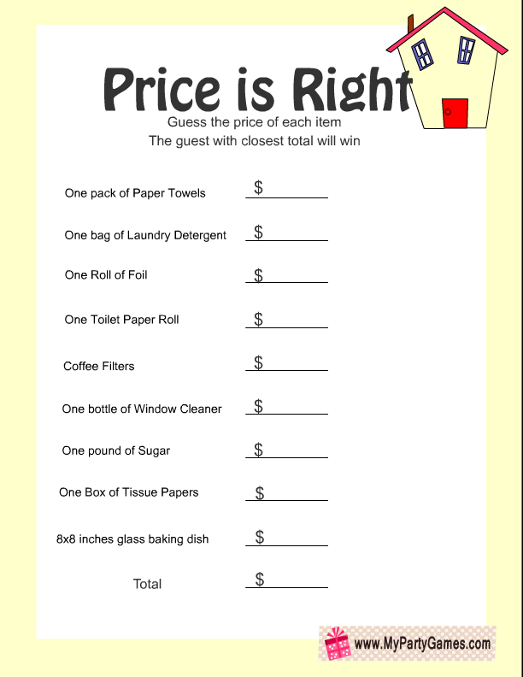

LG Television 75 ´´

Samsung Galaxy Tablet

EPSON Printer

USB Flash Drive 256 GB

Smartphone

Canon Camera

Headphones

Nintendo Switch

HP Laptop



LG Television 75 ´´

Samsung Galaxy Tablet

EPSON Printer

USB Flash Drive 256 GB

Smartphone

Canon Camera

Headphones

Nintendo Switch

HP Laptop

**Annex 2**

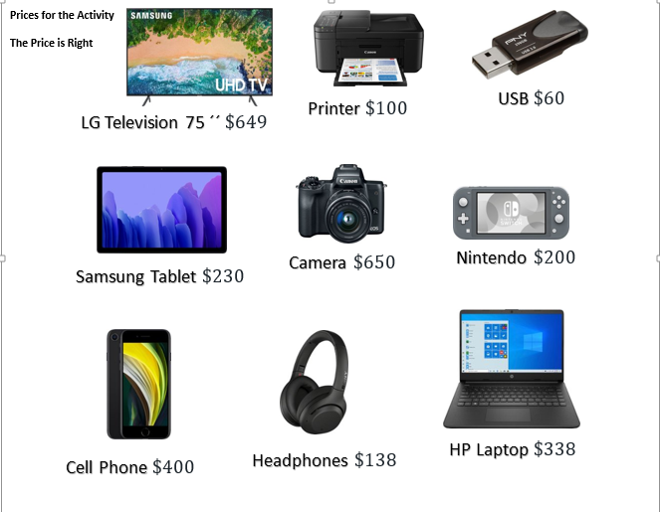

**Annex 3**

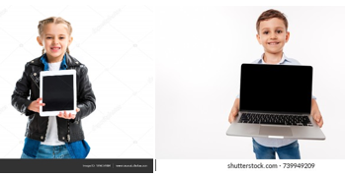

**Annex 4**

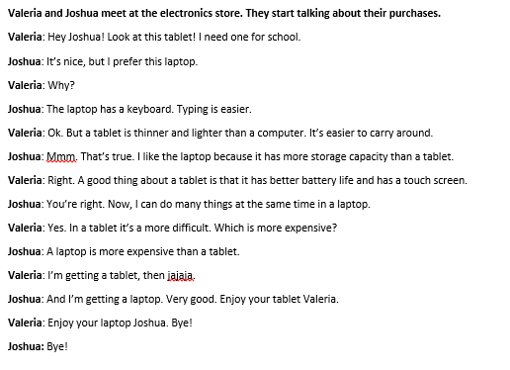

**Annex 5**

**Suffixes Worksheet**

Examples of sentences with common suffixes.

1. You never lie. You are a very **truthful** person.

2. Mumps is a disease with **painful** swellings in the salivary glands.

3. My smartphone’s battery is dead. My phone is **useless** in this moment.

4. A superhero is **fearless**. They have no fear at all.

5. She acts **friendly** with everyone.

6. We have a music lesson **weekly**.

7. A **washable** marker is used in the whiteboard.

8. My **lovable** puppy is so cute!

9. We must fight back against **pollution** to help the environment.

10. The teacher was very happy with the students’ **participation**.

11. I like to do a mathematical **division** instead of a multiplication.

12. I have a flat screen **television** in my bedroom.

13. The students returned to school full of **excitement**. They were really happy to see their friends.

14. The woman was very happy to tell her family about her **engagement**.

**Annex 6**

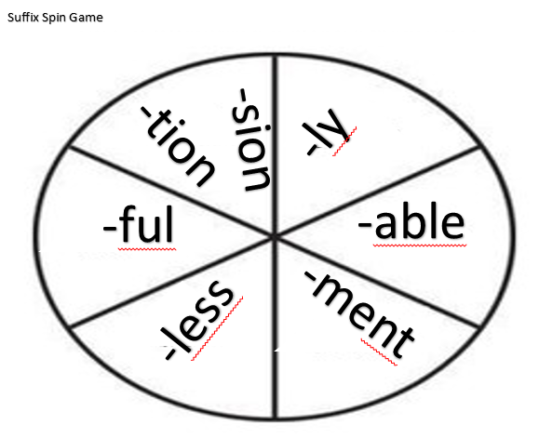

|  |  |  |  |  |  |  |  |  |  |
| --- | --- | --- | --- | --- | --- | --- | --- | --- | --- |
| **Term: II** | | **Level: Fifth Grade** | | | **Unit: 3** | | | **Week:4** | |
| **Domain: Socio-interpersonal** | | | | **Scenario:** Connecting Electronically | | **Theme:** Operating and Taking Care of Electronic Devices | | | |
| **Enduring Understanding**: Electronic devices are instruments used for a variety of purposes and the ways in which people use them can have positive and negative effects. | | | | | | | | | |
| **Essential Question:** How can electronic devices help and hurt us? | | | | | | | | | |
| |  | | --- | | **Dimensions** | | **1.** **Ways of thinking (X )** | | **2. Ways of living in the world  (X )** | | **3. Ways of relating with others  (X )** | | **4. Tools for integrating with the world  (X )** | | | | | | | | | | |
| **Learn to Know** | | | | **Learn to Do** | | **Learn to Be and Live in Community** | | | |
| **Grammar & Sentence Frames**  Modals can/could/should’   * You should buy a _____ (computer) instead of a tablet. * You could ___ get an iPod.   **Phonemic Awareness**  **Review**   * Reading contractions. (e.g., like it’s, isn’t, don’t, doesn’t, aren’t, shouldn’t, what’s, there’s) in different sentences and texts.   **Vocabulary**  **4.Operating and taking care of electronic devices**  Basic parts of a smartphone   * Power supply * SIM Card * Battery * Key pad * Screen   Appropriate use of an electronic device   * Tips * Safely * Password * Mean * Inappropriate * Uncomfortable   Action Verbs  How does the phone work?   * Turn on/turn off * Charge the battery. * Click on * To receive a call. * Set * Download * Post * Share * Spend * Respond | | | | **Function**  Describing the proper use of electronic devices in my life  Describing the uses of electronic devices in life  **Discourse Markers**  Sequence adverbs-past tense  First, next, then, finally | | **Psycho-social**  **Socio-cultural**  idioms/ phrases | | | |
| **Assessment Strategies & Evidences of learning**  (Diagnostic, formative, summative) | **Goals** | | | **Pedagogical Mediation/ Didactic Sequence** | | | | | **Time** |
| Learner… | Learner can | | | **Pre-teaching**  **Routine:** Greeting students, checking attendance, checking-in with students and go over any assignment.  **Connecting**  **Warm up**  The teacher describes four different electronic devices by telling students what it is used for and any specific external characteristic of the device. Students wait until the teacher is finished and raise their hands to say the name of the device. Example: This is a small device that I usually carry in my pants pocket. I use it to chat and call friends.  Students answer: It’s a cellphone.  **Activation of Prior Knowledge**  The teacher writes/projects the statements below on the board. The teacher tells students that these are sentences about the use of electronic devices. He asks students to think if every action is a “Should” **✔** (recommendation) or a “Shouldn’t” **X** (not recommended). After a short while, the teacher reads the statements out loud and if the students consider that it is a “Should”, they raise one hand. If they think that it is a “Shouldn’t”, they will cross their arms to form an “X”.   1. Use your cellphone to chat during the English lesson. 2. Call your parents if you are in an emergency. 3. Take pictures of other students. 4. Mute your cell phone before starting your class.   **Modeling**  The teacher uses the following examples to explain how to use should and shouldn’t in context. Students can mention examples from week 3.  Examples:    You **should** call your parents if you are in an emergency.  You **should** mute your cell phone before starting your class.  You **shouldn’t** use your cellphone to chat during the English lesson.  You **shouldn’t** take pictures of other students.  **Clarification**  **Clarifying**  The teacher reads some statements, and if the statement is something that is not recommended, they will add the words “You shouldn’t” at the beginning while shaking their heads to emphasize the negative. If it is something that they recommend, they will add the words “You should” at the beginning and nod their heads.  Example:  Take pictures of other students.  **You shouldn’t** take pictures of other students. (head shake)  Call your parents if you are in an emergency.  You **should** call your parents if you are in an emergency. (head nodding) | | | | |  |
| **S.P.1.** Talks briefly about familiar topics, such as technology.  Indicator of learning:  **S.P. 1.1.** brainstorms simple phrases and sentences about uses of technology in daily life  **S.P.1.2.** uses simple phrases and sentences about uses of technology in daily life as a form or rehearsal.  **SP.1.3.** talks briefly about uses of technology in daily life using complete sentences. | **S.P.1.** talk briefly about familiar topics, such as technology. | | | **Connecting**  **Pre-task** The teacher writes down the following question and options on the board:What is the video about?  1. It’s about the characteristics of cell phones. 2. Playing games with cell phones. 3. It’s about how to use cell phones safely.   The teacher tells the students that they are going to watch a video, and they will have to answer the question above with one of the two options. The teacher plays the following video: [**https://www.youtube.com/watch?v=Y889t-P2VwE**](https://www.youtube.com/watch?v=Y889t-P2VwE)  When the video is over, the teacher asks the students to raise their hands if they picked number 1. And raise their hands if they picked number 2.  The teacher presents the goal of the lesson by writing “Talking about the proper use of cell phones”.  Teacher plays the video one more time and tells students that they are going to pay attention and write down at least 2 tips from the video. If they want to write more tips, it is allowed.  After that, the teacher asks students to share their answers, and he/she writes them down on the board, he/she makes sure the spelling is correct. The teacher should make sure that there are **seven** tips on the board. The teacher writes down the phrases as they are in the video. Then, he/she asks students for help to turn them into recommendations using “should”.  1. Set a password. (You should set a password.)  2. Get permission to download. (You should….)  3. Respond only to numbers you know. (You should….)  4. Don´t share private information. (You shouldn’t share private information.)  5. Think before you post. (You should….)  6. Ask for help if something makes you uncomfortable. (You should….)  7. Take a break, spend time with family and friends. (You should….)  Teacher asks students to listen and repeat the different phrases. The teacher should pay attention and give extra practice for those words that students have trouble with.  The teacher introduces the task: There is a campaign at school about how to use a cell phone safely. You were chosen to share four tips with younger students from school. Use should and shouldn’t for the recommendations that they choose. Write down the discourse markers on the board and let them know that they have to use them. (Students can make a poster, Power Point presentation, Tik-Tok, etc.)  **Clarification**  **Task-rehearsal**  The teacher models the task. He/she acts out the presentation making the recommendations and using discourse markers (First, Next, Then, Finally).  First, students choose or brainstorm some sentences related to the use of technology in daily life.  Next, students sit down to prepare and rehearse their presentation. They do this individually. Once they have their presentation ready, they can rehearse with a partner. They can include key words in the poster, but not complete sentences. They will let the teacher know when they are ready. If some students finish quickly, the teacher can listen to those students individually and assess them. Students can be allowed to practice in pairs once they have their speech ready.  **Application/ Collaboration**  **Task completion**  Students make groups of four students. One student at a time, presents to the rest. The teacher gives them a handout with a simple rubric where the other three evaluate the presentation of his classmate by writing down the number of tips or ideas shared. The teacher can walk around the class to listen to some of the students, and at the end, he/she can ask for volunteers to go to the front and present.   |  |  | | --- | --- | | Students |  | |  | Presents 4 tips Yes No  Uses should Yes No  Uses shouldn’t Yes No  Uses 4 discourse markers Yes No | |  | Presents 4 tips Yes No  Uses should Yes No  Uses shouldn’t Yes No  Uses 4 discourse markers Yes No | |  | Presents 4 tips Yes No  Uses should Yes No  Uses shouldn’t Yes No  Uses 4 discourse markers Yes No |   The teacher walks around the groups and carries out his/her assessment for every kid.  **Task assessment**  Small group brainstorming: In the same previous groups, they will say the name of another electronic device different from the cell phone, and everyone in the group has to mention an idea about its proper use. Students participate in self-assessment of task performance. | | | | |  |
| **R.PA.3.** Reads contractions and word endings -tion, --sion in different sentences and texts.  Indicator of learning:  **R.PA.3.6.** Reads contractions **(**e.g. haven´t, aren´t, it´s, isn´t, don´t, didn´t, that´s, what´s) in different sentences and texts. | **R.PA.3.** Decodes English graphemes and phonemes in different environments. | | | **Connecting**  **Pre-task**  The teacher writes down the following word on the board: “I’m”. The teacher asks students if they know which the two words that are joined by the apostrophe to create this new word are. Use the Think, Pair, Share strategy to go over the question (Think: students think individually of the answer. Pair: students share answers in pairs. Share: volunteers share answers with all the group).  After listening to the students answers, he/she briefly explains that the two words forming the word are “I + am”. And those two words can turn into a single one with the use of an apostrophe. As a result, the pronunciation of the word changes, too.  Teacher introduces the goal of the lesson: Reading contractions  Teacher gives/projects/writes the following text below and asks students individually to underline/write/ circle all the contractions that they see in the text.    When students are finished, the teacher asks them to volunteer and say the words that they found. He/She writes them on the board.  **Clarification**  **Task-rehearsal**  The teacher reads every contraction out loud. These are the words that were written on the board in the previous exercise. Students just listen.  Then, he/she reads them again and asks learners to repeat.  Now, the teacher reads every sentence from the text that has a contraction out loud for students to repeat.  Pair work: Students get in pairs to practice reading the sentences with contractions. One student points out to a sentence with a contraction randomly and the other reads the sentence. When one is over reading, they switch roles. Teacher asks students to keep score of how many contractions they can read correctly individually and as a pair.  **Application/ Collaboration**  **Task completion**  In the same pairs, one student at a time will read the text. The classmate will keep track of how many contractions he/she can read correctly.  **Task assessment**  The teacher will call out every pair, and they have to read one sentence out loud from the ones on the following list. If the pronunciation of the contraction in the sentence is correct, the rest of classmates stand up and repeat the contraction. Students participate in self-assessment of task performance.  1. My cell phone doesn’t have a protective case.  2. This computer isn’t new.  3. I don’t post my family photos on Facebook. | | | | |  |
| **W.2.** Composes short dialogues, advertisements related to technological devices and its uses  Indicators of learning  **W.2.1.** writes a short dialogue or advertisements related to technological devices and its uses following a pattern provided by the teacher.  **W.2.2.** edits his/her own dialogues and advertisements related to technological devices and its uses checking correct use of capitalization, punctuation, grammar and spelling. The learner uses should/shouldn’t to write down recommendations. | **W.2.** compose short dialogues, advertisements related to technological devices and its uses. | | | **Connecting**  **Pre-task**  The teacher shows the following picture to the students, or any other similar that portrays an incorrect use of a cell phone.    He/She asks the students: What is wrong with this picture?  Is she following the tips to properly use a cellphone?  Teacher asks learners: What do you think that we are learning today?  He/she listens to the students and then introduces the goal: We will be working on how to write a short poster about the proper use of technological devices.  The teacher asks them about the things that one person has to remember when using a cell phone properly (recommendations and tips: use of should and shouldn’t). As students participate, he/she or the students write the tips down on the board. He/She asks learners for full statements or sentences.  The teacher creates a poster where he/she states 2 tips that must be followed when using a cellphone. In this way, the teacher models the task for the students. Remember using recommendations, discourse markers, and tips.  The teacher introduces the task: Many young students are getting telephones nowadays, but many of them do not know how to use the properly. The school is organizing a campaign to inform the youngest ones about the proper use of electronic devices. So every student has to prepare a poster and give a short speech to young students from lower grades.  **Clarification**  **Task-rehearsal**  Students gather pictures and sentences that they may use to create their poster about how to use a cellphone properly (The teacher should ask students to bring those materials as homework.). They have to include at least 5 tips to properly use a cell phone. Students can use digital devices and apps to work on the poster.  Individually, students organize their ideas. They may write a draft first and show it to the teacher, so he/she can help them with any aspect of the writing and/or organization. Students have to think of a title for the poster.  **Application/ Collaboration**  **Task completion**  Each student will create a poster to advertise the proper use of a cell phone. Each student can bring markers, color pencils, and a sheet of paper to create his\her poster. If students have access to technological devices in the classroom, they can create the poster digitally. They can create a blog entry if the conditions allow it.  The student should include **5** tips to properly use a cell phone using recommendations and discourse markers.  As a final step, students edit their advertisements by checking correct use of capitalization, punctuation, sentence frames and spelling.  **Note** At the end of this activity the teacher can paste the poster around the school or near the English classroom, so the students from other groups can learn about this. If they use digital means, they can upload or share the presentations using TEAMS or any other application. Another possibility is to actually take the students to lower level groups, bring their posters and make the presentations.  **Task assessment**  Students brainstorm 3 technological devices that they usually use. They are written on the board.  Each student will choose one of those devices and write 3 tips to properly use it. Students participate in self-assessment of task performance.  **Student self-assessment grid**   |  |  |  |  | | --- | --- | --- | --- | |  | Level of achievement | | | | Assessment Indicators  I can ... | Not achieved yet | In progress | Achieved | | **S.P. 1.1.** brainstorms simple phrases and sentences about uses of technology in daily life |  |  |  | | **S.P.1.2.** uses simple phrases and sentences about uses of technology in daily life as a form or rehearsal. |  |  |  | | **SP.1.3.** talks briefly about uses of technology in daily life using complete sentences. |  |  |  | | **R.PA.3.6.** Reads contractions **(**e.g. haven´t, aren´t, it´s, isn´t, don´t, didn´t, that´s, what´s) in different sentences and texts. |  |  |  | | **W.2.1.** writes a short dialogue or advertisements related to technological devices and its uses following a pattern provided by the teacher. |  |  |  | | **W.2.2.** edits his/her own dialogues and advertisements related to technological devices and its uses checking correct use of capitalization, punctuation, grammar and spelling. The learner uses should/shouldn’t to write down recommendations. |  |  |  | | | | | |  |
| **Integrated Mini-Project** | | | | | | | | | **Time** |
| In small groups,  - Planning, creating collaboratively a technology exhibition in the classroom describing each device (price, advantages and disadvantages) and their corresponding definition using flashcards, articles and magazine clippings for reporting to small groups or whole class.  - Another idea is creating a poster of one or more specific device(s) (drawings, brainstorming, ways to take care, advantages and disadvantages)  - Make a collage with drawings, magazine clippings, articles and all the vocabulary seen in class.  - Participating in individual assessment. In all activities, encourage students to ask presenters different questions. | | | | | | | | |  |
| **Reflective Teaching** | | | | | | | | | |
| What worked well | | | What didn’t work well | | | | How to improve | | |
| **Enduring Understanding Reflection** | | | | | | | | | |
|  | | | | | | | | | |

**Links for Materials**

**Links Week 1**

Technology and the family

<https://www.youtube.com/watch?app=desktop&v=37OLJPjoews>

My Favorite Electronic Device

<https://drive.google.com/file/d/1JEFJGsYXOyufqRpqIyhMEXlObQQBIV5G/view?usp=sharing>

**Links Week 2**

The Roulette Game

<https://drive.google.com/file/d/1PzesRYtIa7pTLCEZCTofLR7J-zZMVSSs/view?usp=sharing>

Looking for an Electronic Device

<https://drive.google.com/file/d/1U3sDlaXMjMRODriGUMOHgFBsyYyfNPFg/view?usp=sharing>

Electronics Store Phone Call

<https://drive.google.com/file/d/1TOwUd3RY5hNM-4M3WmTHUxKVPSxepIzN/view?usp=sharing>

**Links Week 3**

Comparing Devices

<https://drive.google.com/file/d/1l1BwxIRLBRUI3URc5nIdqMXEPbrIev9X/view?usp=sharing>

Suffixes ful, less, ly, able

<https://www.youtube.com/watch?v=U_6mfwXe3Bo>

The Electric Company - tion

<https://www.youtube.com/watch?v=cmEnH19skeE>

Phonics Fun!!: -sion & -tion suffixes

<https://www.youtube.com/watch?v=3OzL705pSk0>

Take Care of Your Computer

<https://www.youtube.com/watch?v=iZbvKhEhmkg>

**Links Week 4**

Cell Phone Safety for kids by a kid!

<https://www.youtube.com/watch?v=Y889t-P2VwE>

**Add list of links distributes per week**

**Créditos y agradecimientos/Acknowledgements**

**Asesor Regional de Inglés de San José Norte**

Randall Centeno Hernández

**Docentes de inglés de primaria de la Dirección Regional San José Norte**

* Viridiana Alvarado Bejarano
* Carolina Bejarano Durán
* Floribeth Blanco Quirós
* Carol Caballero Rojas
* Rita Herrera Zúñiga
* Marta Mora Quirós

**Grabación de audios/Audio Recordings**

* Analin y Fabrizio Huirse Semana 1 “My Favorite Electronic Devices” Semana 2 “Looking for an Electronic Device”
* Jeffery Lochie Smylie y Elizabeth Ann Martens Semana 2 “Electronics Store Phone Call”
* Carina Carrol y Pablo Salazar Semana 3 ”Comparing Electronic Devices”